Work Order: Development and launching of the MH / MHP* HOST eLearning Platform
We are herewith submitting all the information required for the implementation of the development and launching of the HOST eLearning Platform of ( Name of the Institution)
Kind Attention.: ___________________________________________________
Particulars of the Institution
S. No | Nature of Information required. | Description of the requirements to be filled by the Institution In-charge. (To create and activate of the HOST eLearning Platform)  (Information is case sensitive) |  | Reasons for Seeking Information
1 | Name of the Institution |  |  | To be displayed in the APP
2 | Organization Code  An auto-generated six-digit code that is used as an identification for your institution |  |  | Auto-generated  But you can propose a SIX DIGIT CODE
3 | Login Credentials required  (The login credentials may however differ slightly from those requested sometimes due to clash in the account names.) | Particulars required to create the HOST: |  | Mandatory Information
3 |  | Organization Name |  | Signature of  In-charge
3 |  | Admin Name |  | Signature of  In-charge
3 |  | Username |  | Signature of  In-charge
3 |  | Mobile No. (1) |  | Signature of  In-charge
3 |  | Mobile No. (2) |  | Signature of  In-charge
3 |  | Email ID (1) |  | Signature of  In-charge
3 |  | Email ID (2) |  | Signature of  In-charge
4 | SMS Package*  *Additional SMS to be purchased | 1000 SMS Free and extra charges thereof.
5 | Scheduled Timeline for creation of Account | Technoserver: One Week |  | Your Package name is mentioned in the quotation

We understand that the information disclosed in the above proforma shall be made available to all its users either partially or in full as per the permissions and securities mentioned in the Terms & Conditions of service. We have gone through the ‘Terms & Conditions’ of service. We shall abide by the ‘Terms & Conditions’ of service at all times during the tenure of this package.
We herewith place the order for the following package.
Name of the Package | MH / MHP* - Technoserver
Strength of the Institution

Please find enclosed the payment details along with this work order in the enclosed proforma as per the estimate mentioned in the Invoice (No.: ________________ Dtd.: ___________)

Signature of the In-charge:
Stamp of the Institution with Date
Invoice / Estimate – MH / MHP – Technoserver
Description: White Label Web & Mobile APPs
Technoserver
White Label App - Organization Code on MH/MHP - Login with your Organization Account*
* Direct Download of MH /MHP ANDROID & IOS APPs - Onboarding + Training + LOGINS
Mindhosts/ MindhostsPlus – IOS – Technoserver Package
Price Per student Per Annum (PSPA) - ₹ 96 Per student Per Annum/- + 18% GST.
MindhostsPlus – IOS – Technoserver Package – Teachers’ Day Offer
For a Student Strength of Up to 500 (±50 Students) |  | Total Estimate ₹7500/-
For a Student Strength of Up to 1000 (±100 Students) |  | Total Estimate ₹10,000/-
Per 100 Students above 1100 Strength |  | Additional Amount of ₹1250/-
+ One-time Onboarding + Training Charges of ₹3000/-

MindhostsPlus Mobile APPs | Download from Play Store & APP Store
Time-Line: One Week from payment Date  Payment Mode: 100% in Advance along with the work order | For Terms of service & Privacy Policy visit  www.indgiants.com ;; www.mindhosts.com  www.mindhostsplus.com
Technoserver: Same Annual Subscription for Three Years: 2026-2029

Director


(For Indgiants Pvt Ltd)

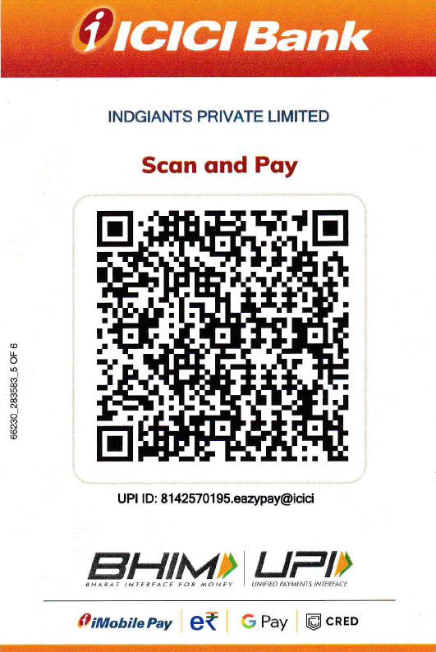
Payment Modes

Payment To M/S Indgiants Pvt Ltd
ICICI BANK LTD; AC No.: 007505019032;
IFSC Code: ICIC0000075
UPI ID: 8142570195.eazypay@icici
UPI ID: indgiants07072020@icici

Payment Details
Date:

Payer Details: _________________________________________________________________
An amount of __________/- (₹_________________________________________________ Only)
has been paid to Indgiants Pvt Ltd (Incl. of 18% Tax) for the Invoice / Estimate raised. _________________ (Mode of Payment) - Transaction ID: __________________________________.

Signature of the Institution In-charge with Date:

